1. Accessing Your Fair Dashboard
When you log in, you will see your Book Fair homepage.
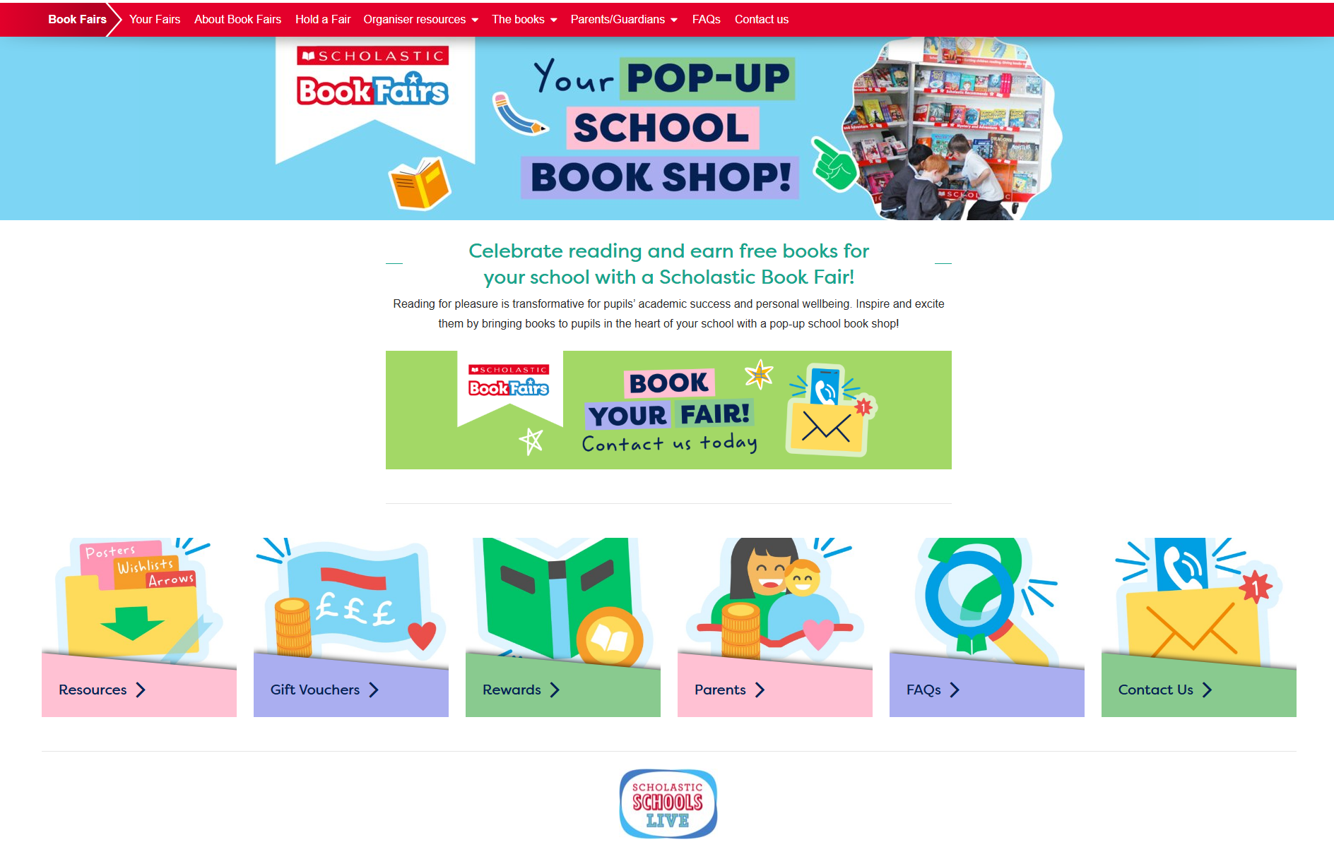
Select Your Fairs from the navigation menu to view your current and previous Book Fairs.
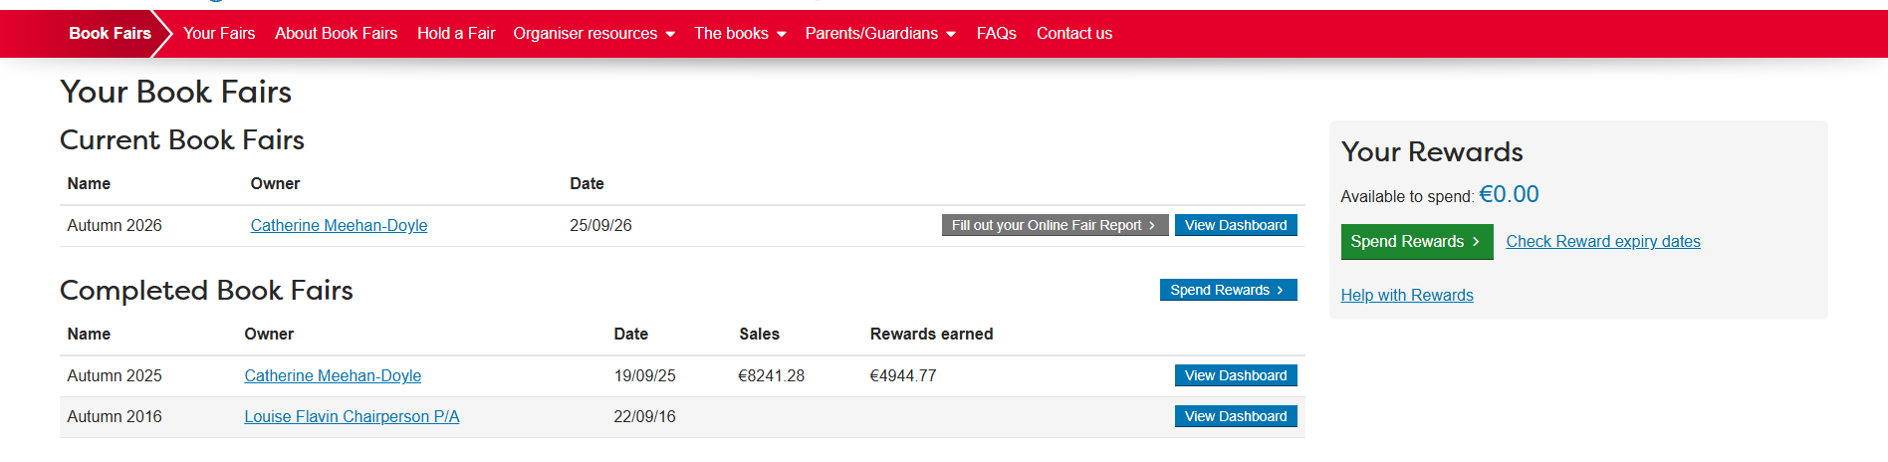
Click View Dashboard to access detailed information about your fair, including sales activity and support tools.
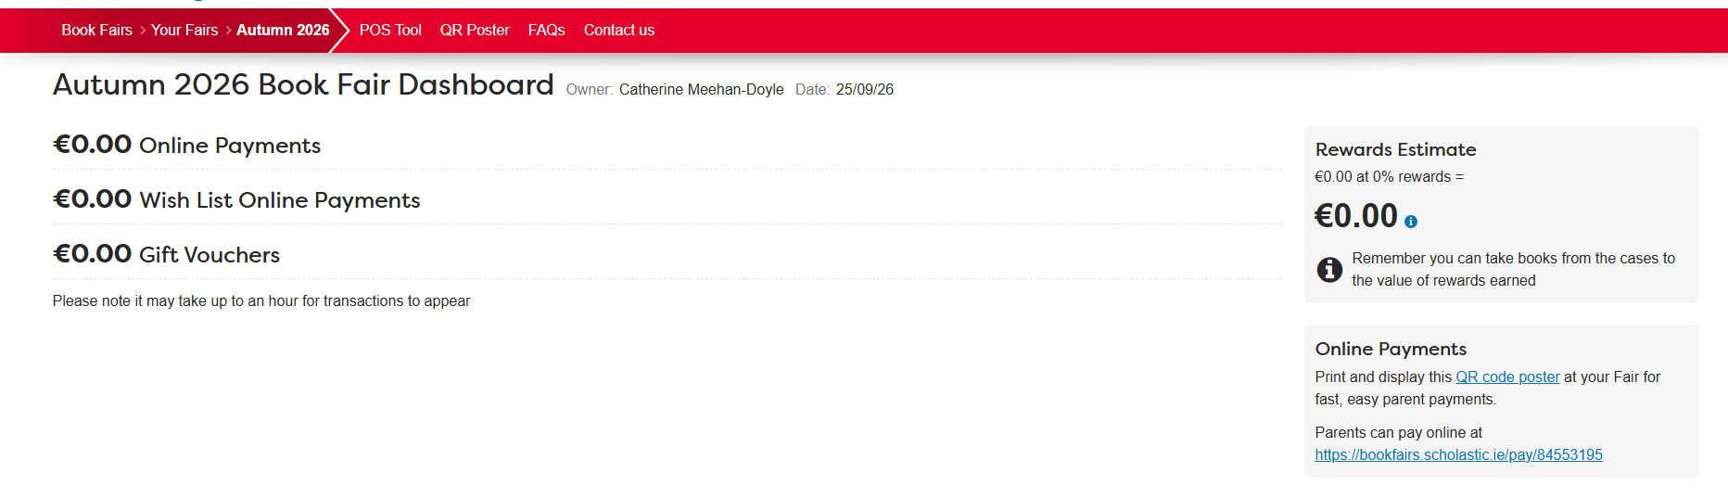

2. Using the POS Tool
Within your Dashboard, select the POS Tool from the navigation bar.
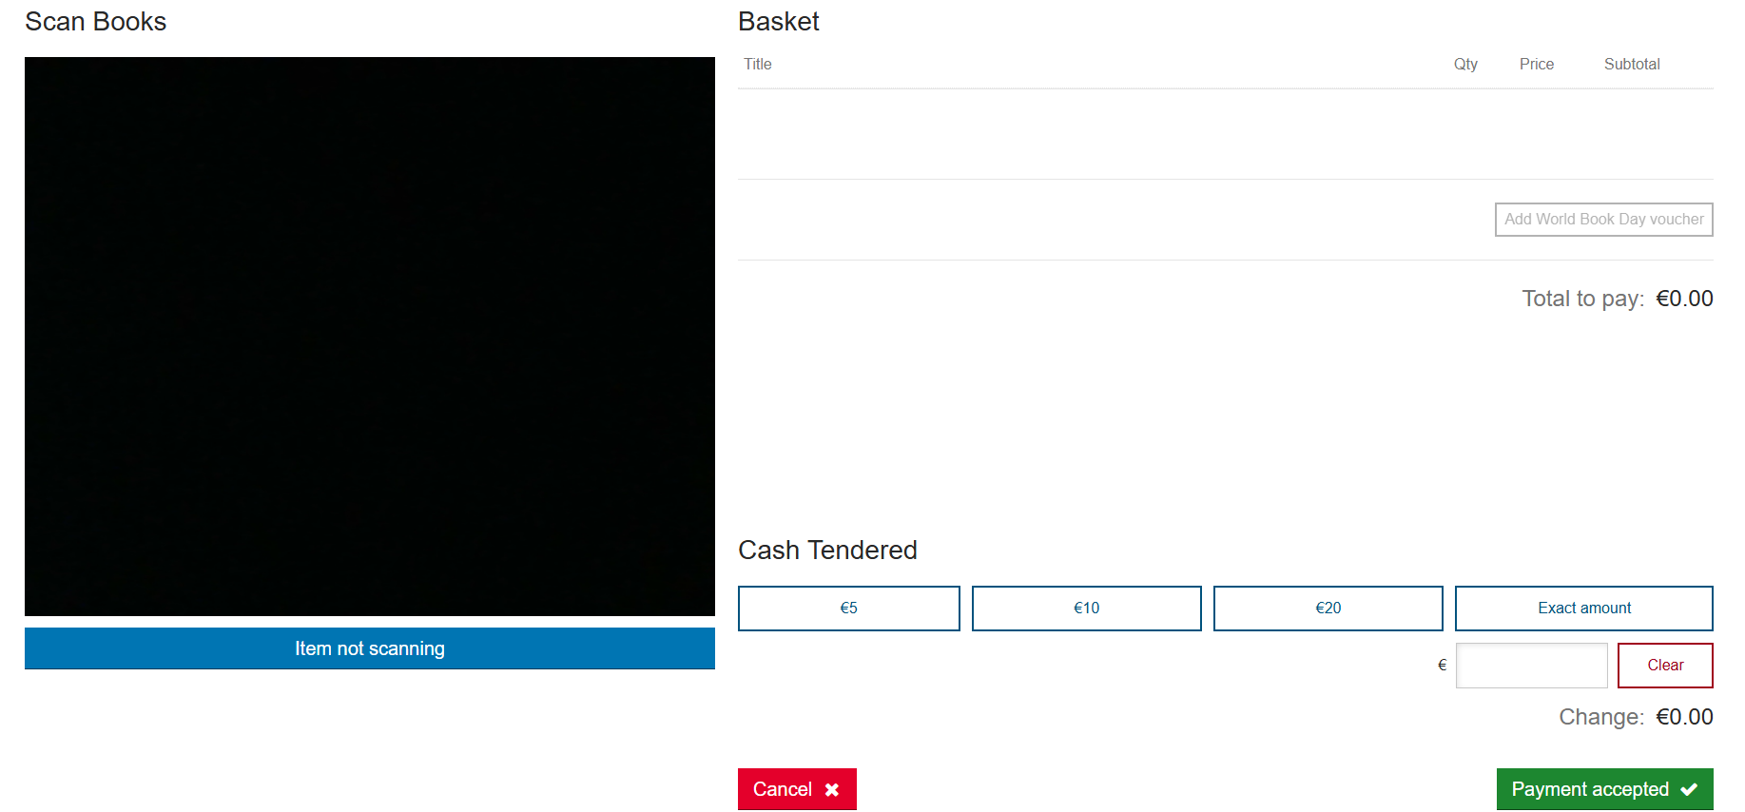
The POS Tool allows you to record cash sales during your Book Fair
To process a sale:
- Scan the barcode on the back of the book.
- The item and price will automatically appear on screen.
- Enter the amount of cash received.
- The system will automatically calculate any change due.
If an item does not scan, select Item Not Scanning and manually enter the item details.
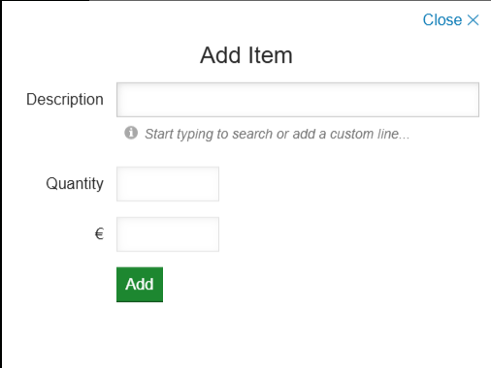

3. Viewing Cash Transactions
All cash transactions entered through the POS Tool will automatically appear on your Dashboard.
You will be able to view transaction totals and summary information.
Please Note: Organisers can view transaction values but will not see individual item details. If required, item-level information can be accessed by Scholastic if you have any queries.
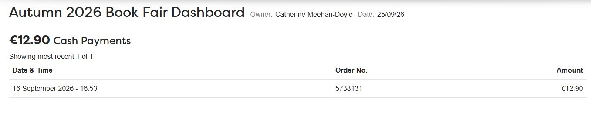
4. Printing Your Fair QR Code Poster
Your Dashboard includes a personalised QR Code poster that can be downloaded and printed for use during your Book Fair.
Select the QR Poster option on your Dashboard to access your fair's unique QR code
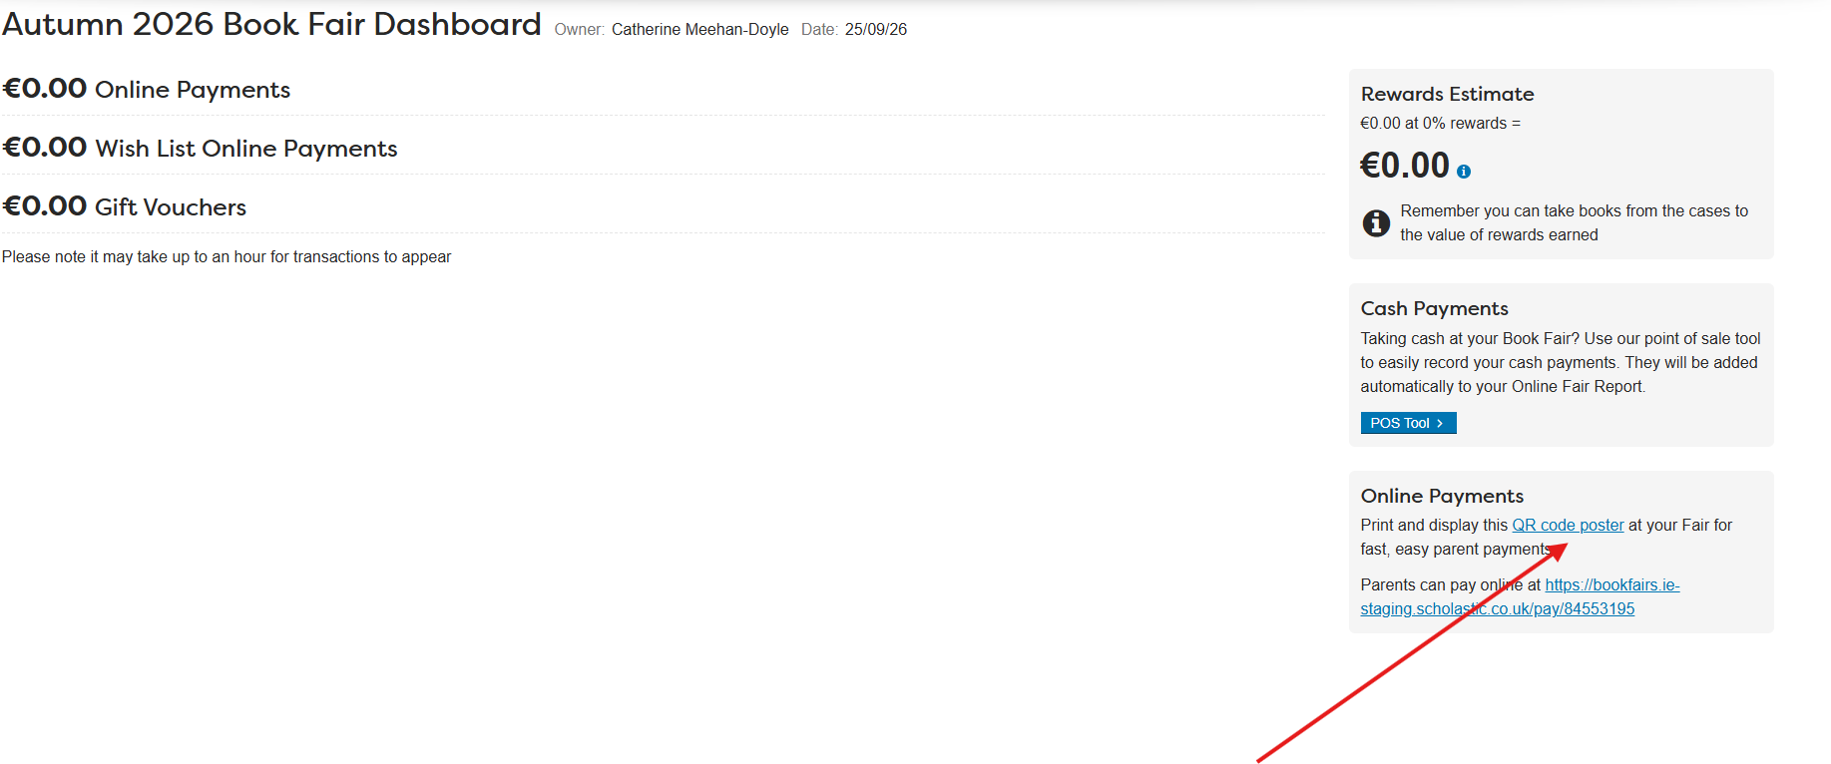

Your QR poster will look similar to the example below.
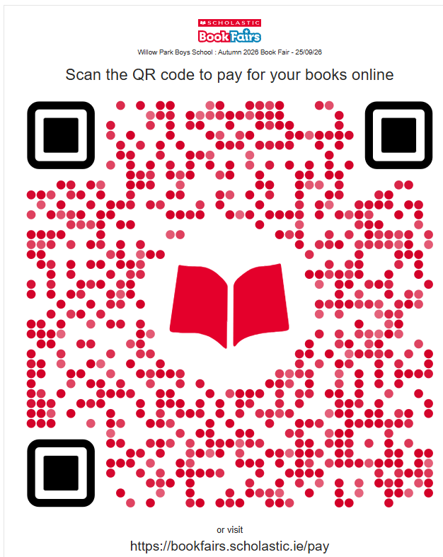

5. Using the QR Code
Parents and visitors can simply scan the QR Code using their smartphone.
When scanned, they will be taken directly to your Book Fair page.
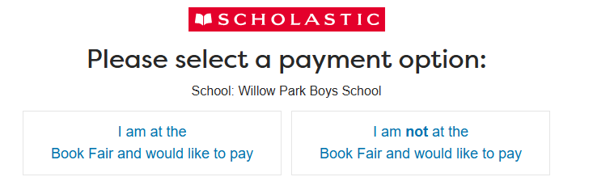 If they are attending the fair in person, they can use the scanning feature to purchase books directly.
If they are not attending the fair, they will be directed to the online Book Fair page where they can browse and purchase books as normal.
If you need assistance with your Dashboard, QR Code, transactions, or Book Fair management, please contact the Scholastic Customer Service Team who will be happy to help.

