{Insert School address here}

Dear Parents/Carers,
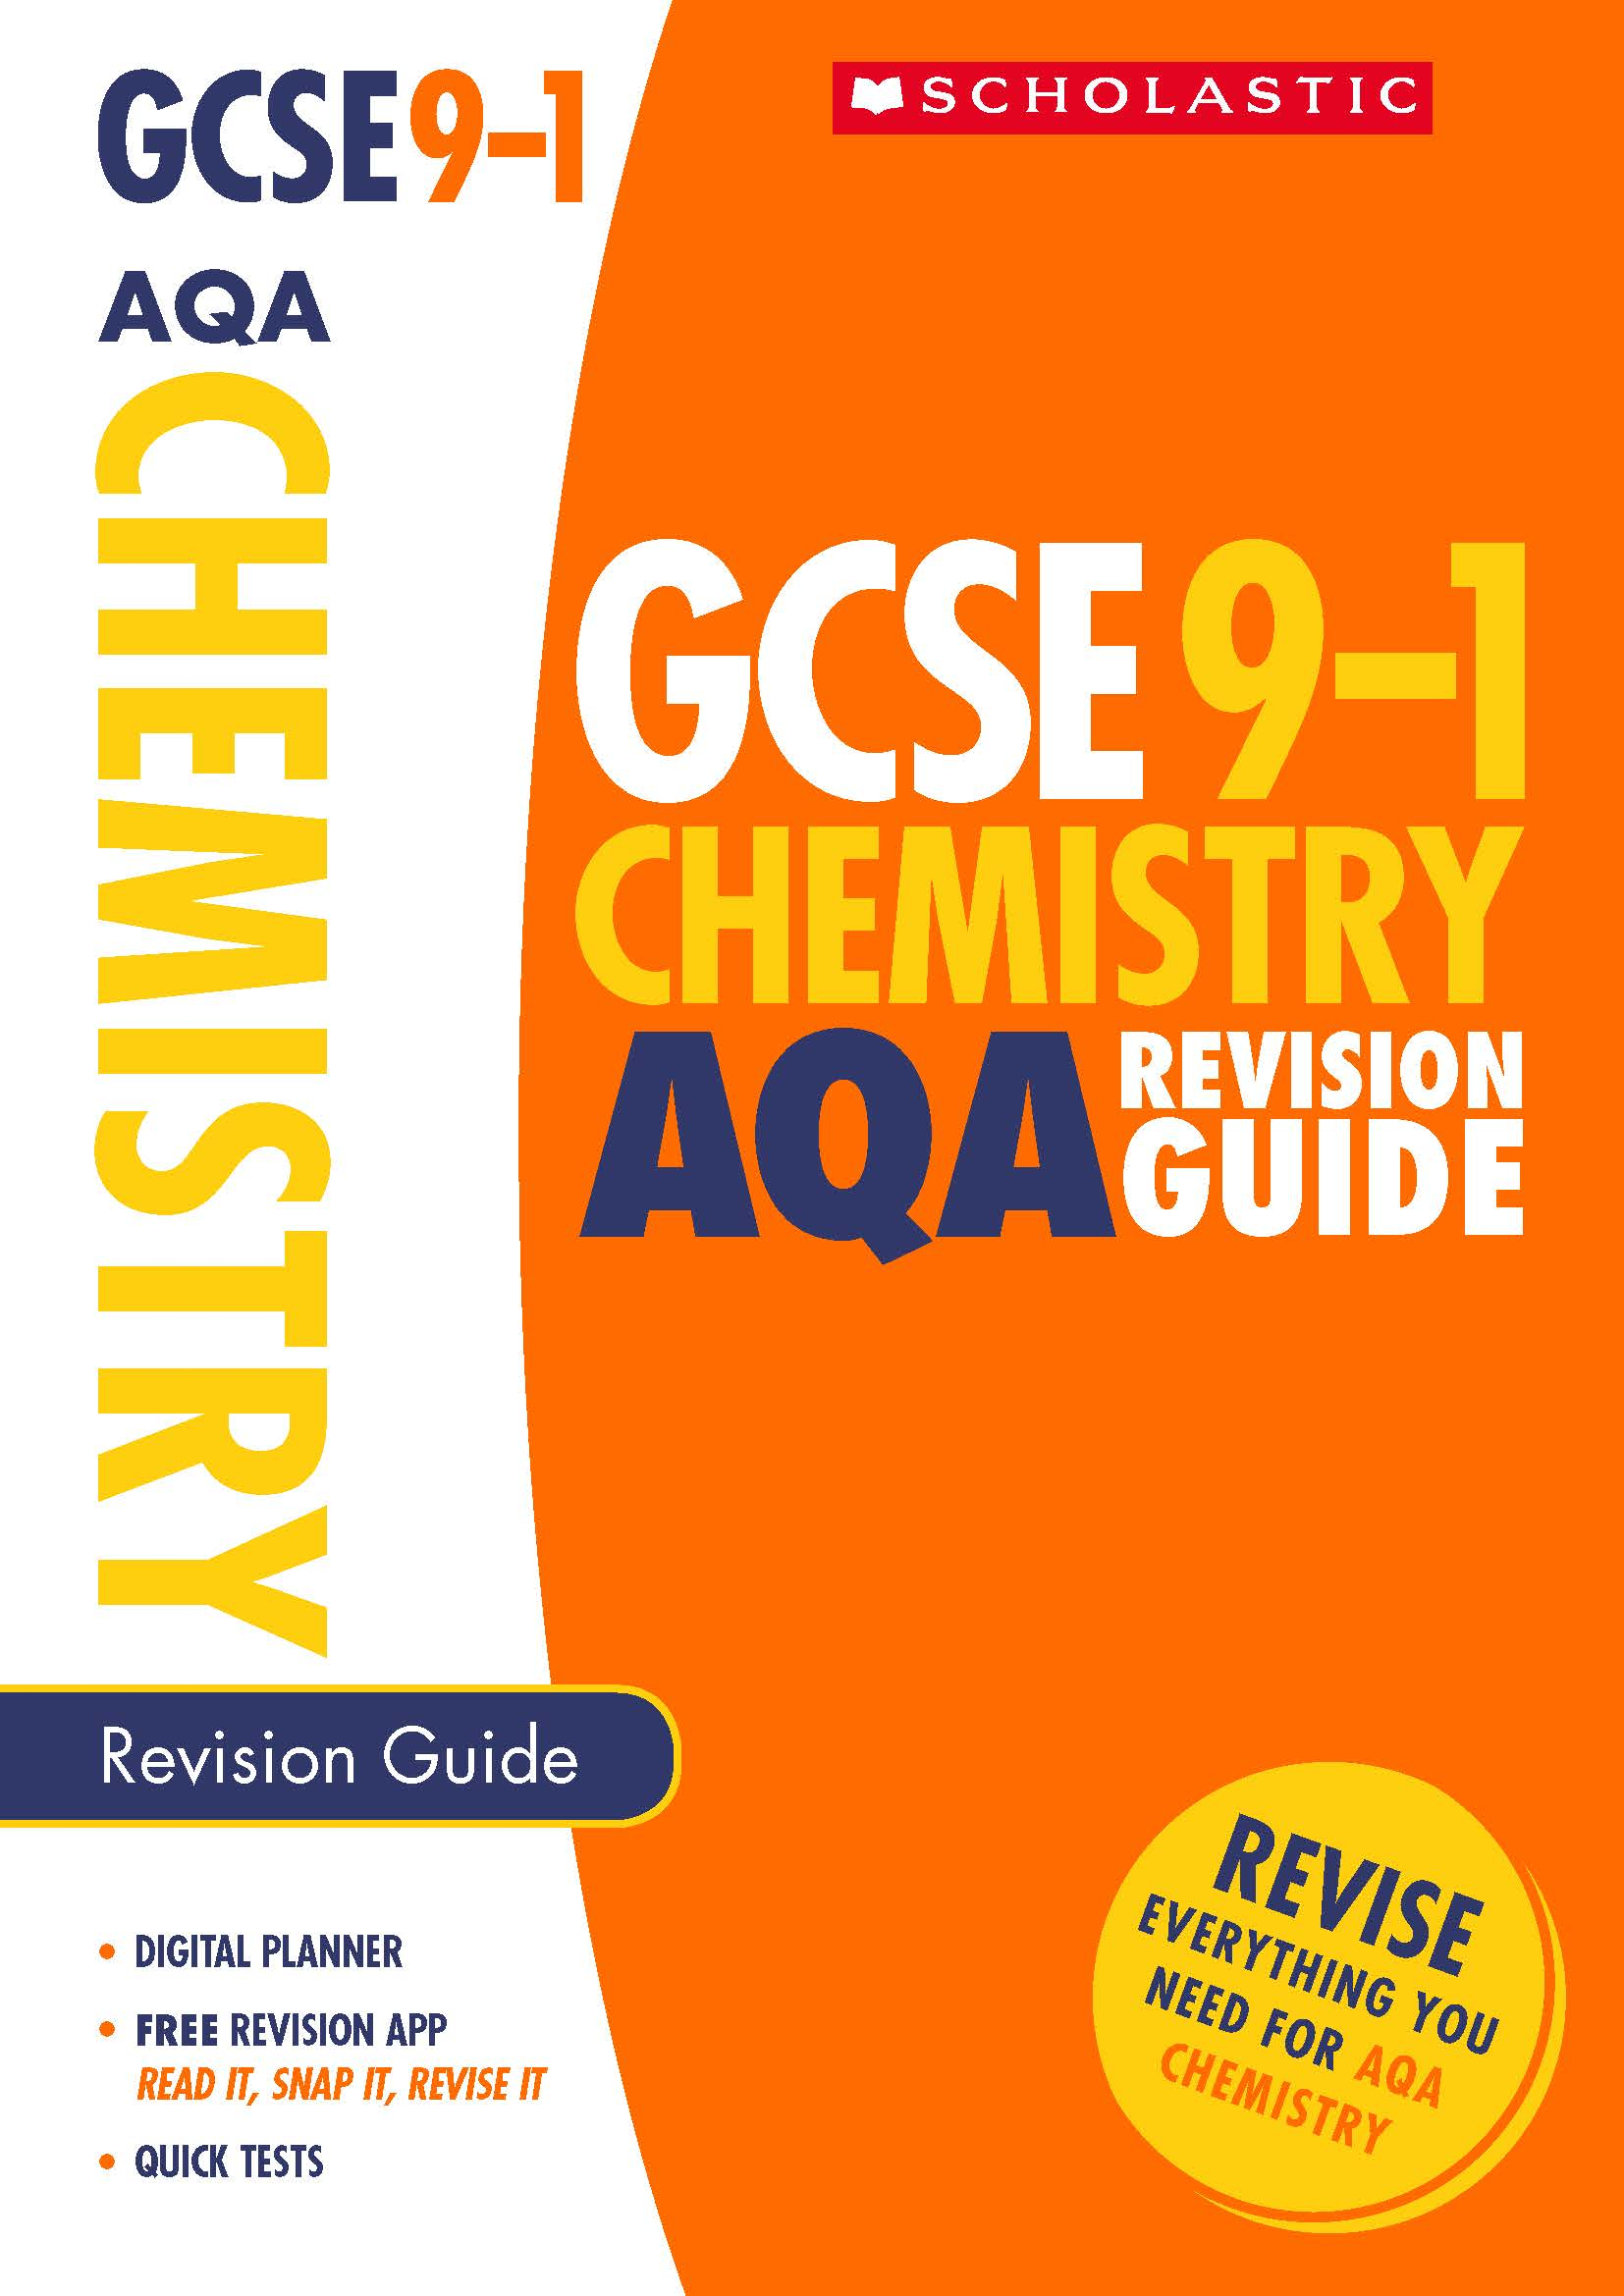
In light of the changes to GCSE Science specifications many of our students are asking us to recommend good, reasonably priced revision guides to help them prepare for the new exams. We are currently recommending the Scholastic 9-1 GCSE Practice and Revision books. These are available to purchase through the school at a discounted price of Enter price

The Scholastic GCSE Practice and Revision books for Science will help your child meet the demands of the new exam specification. I would encourage every child studying Biology or Chemistry to purchase a revision guide in order to ensure the best result possible.
Chemistry revision guide

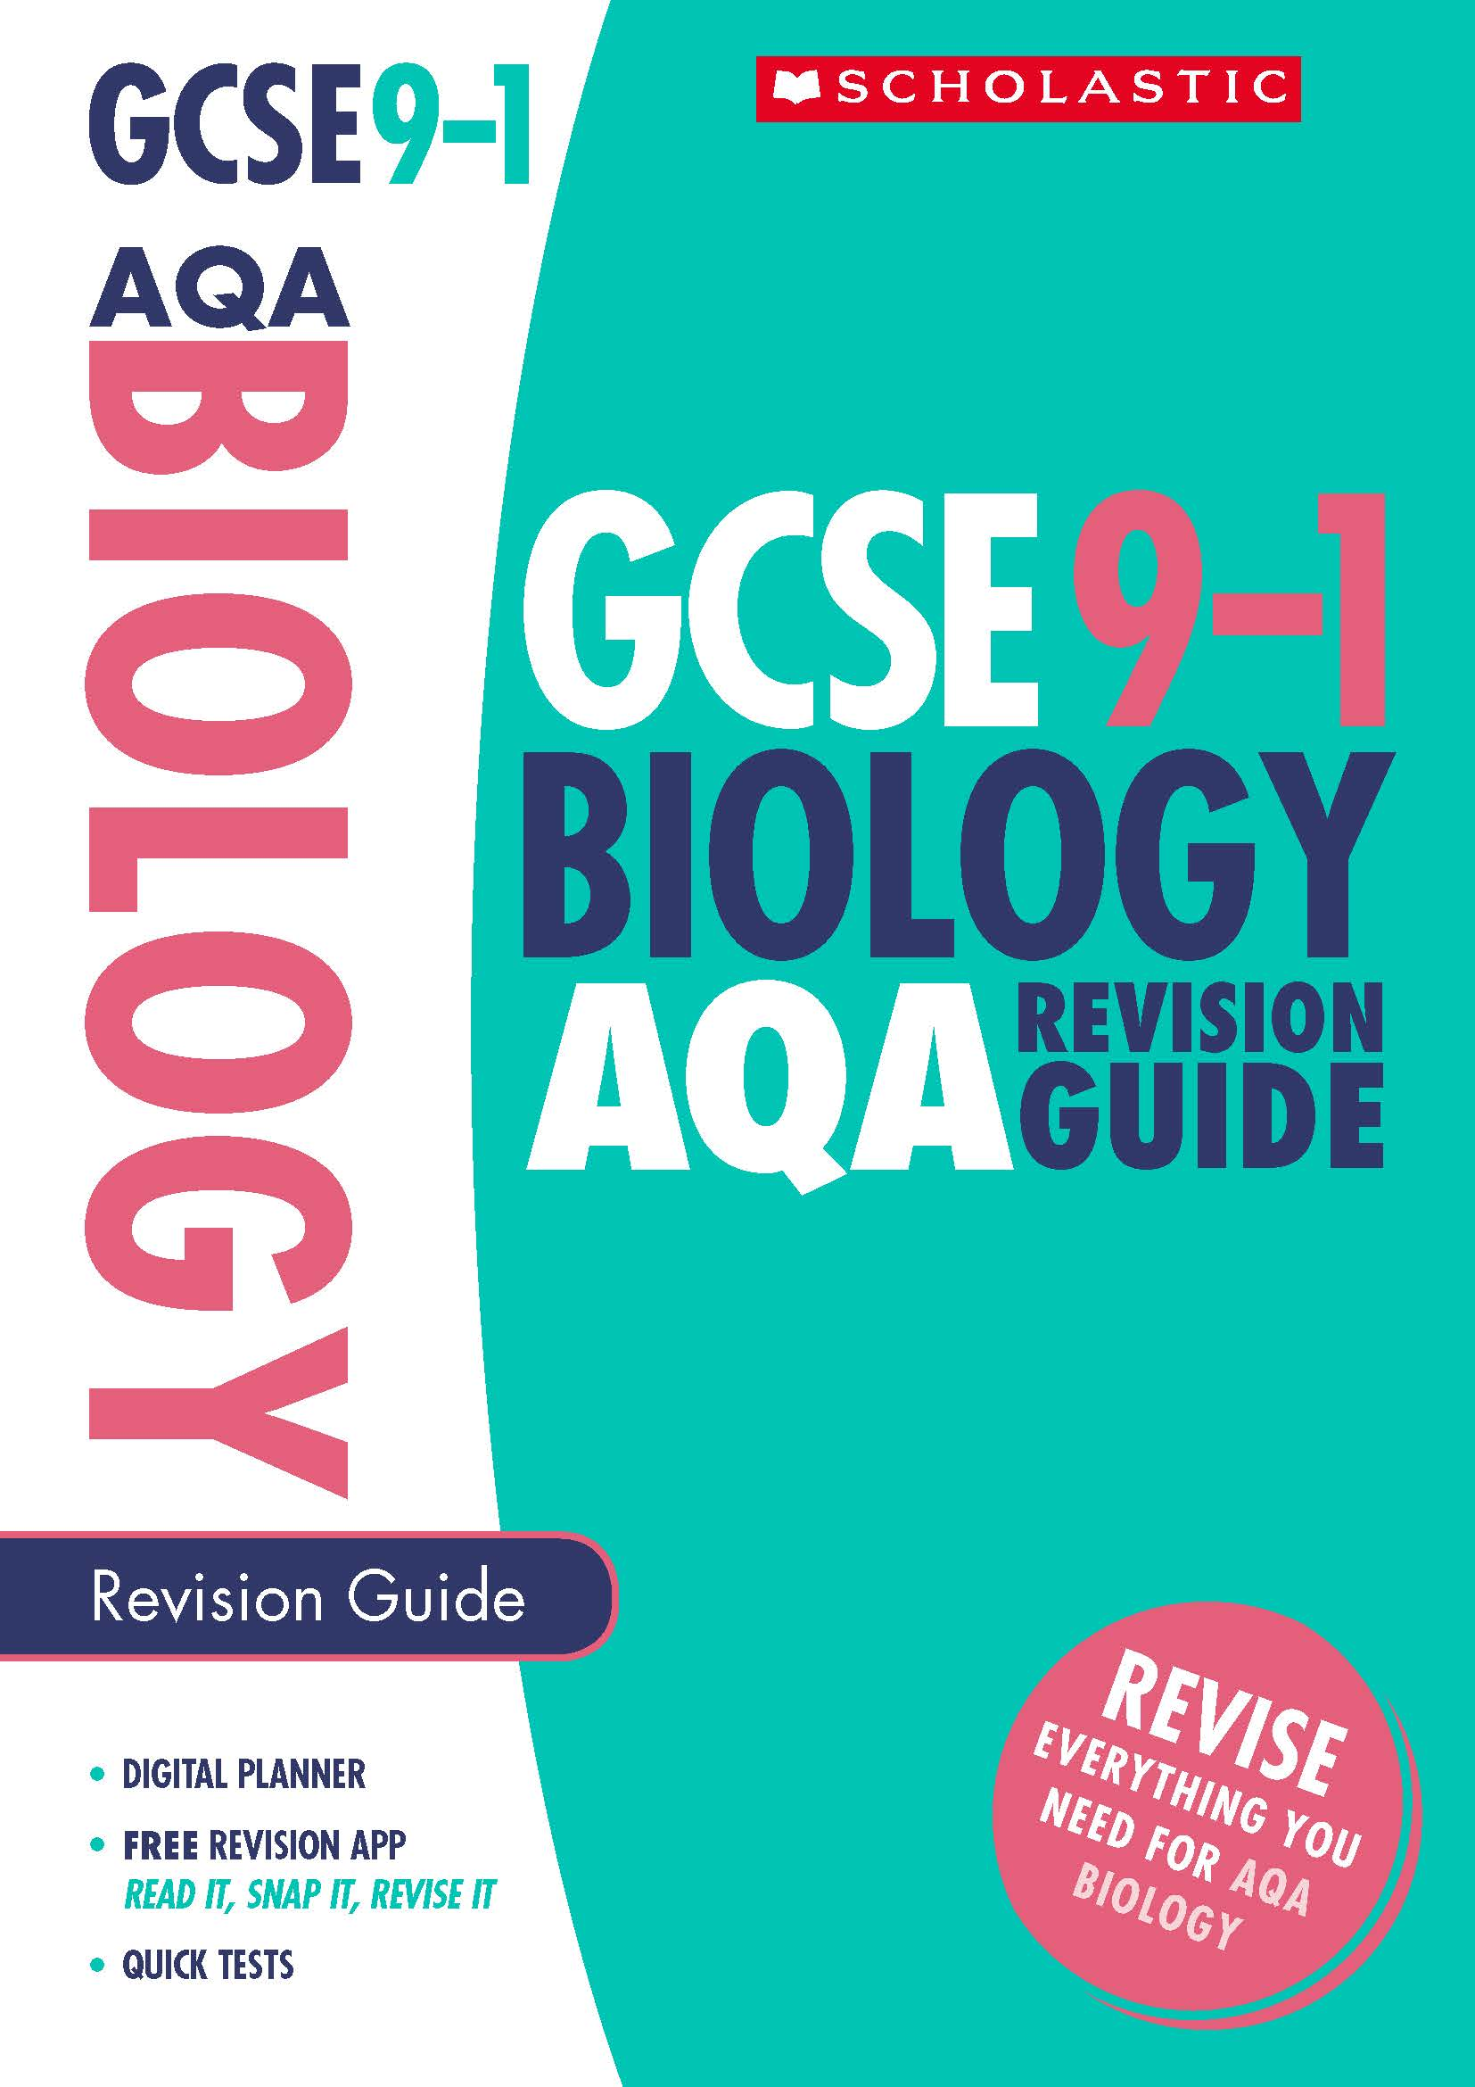
The book that I recommend for your child is: Select title
If you wish to take advantage of this offer please complete and return the slip below, enclosing the correct payment. The final date for ordering is Enter date
Thank you for your continued support.
Yours sincerely,
Biology revision guide

Name of child:_ _ _ _ _ _ _ _ _ _ _ _ _ _ _ _ _ _ _ _ _ _ _ _ _ _ _ _ _ _ _ _ _ _ _
Class: _ _ _ _ _ _ _ _ _ _ _ _ _ _
I enclose the amount of £:_ _ _ _ _ _ _
Signed: _ _ _ _ _ _ _ _ _ _ _ _ _ _ _ _ _ _ _ _ _ _ _ _ _ _ Date:_ _ _ _ _ _ _ _ _ _ _ _

