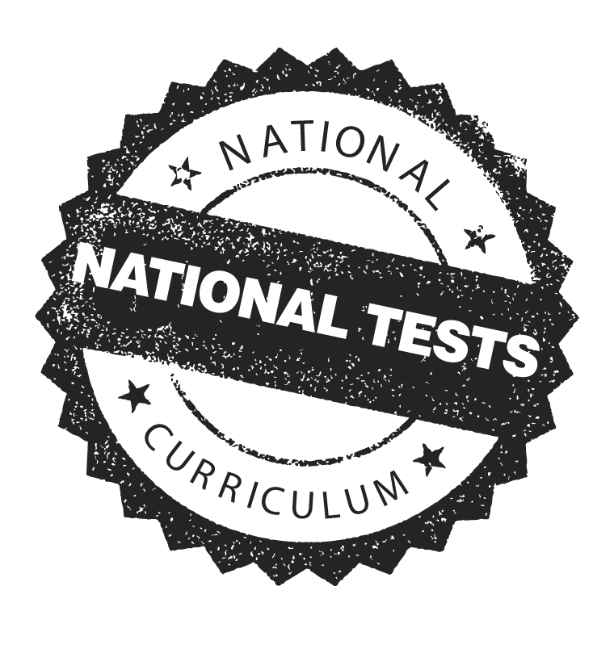
{Insert School address here}

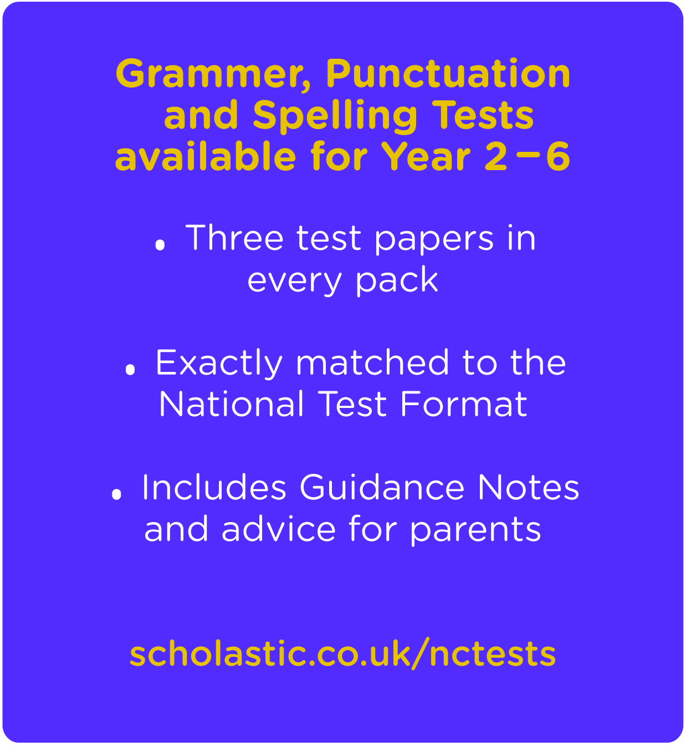
Dear Parents/Carers,
In light of new National Curriculum Tests for years 2 and 6 we have decided to focus on grammar, punctuation and spelling over the next few terms in English.
In order to support pupils at home we recommend the Scholastic National Curriculum Tests for Years 2‒6, pictured below.
The test packs include:
- Three authentic test papers exactly matched to the new test format
- Extra support with guidance notes and tips
The cost of each National Tests pack is £7.99. If you would like to purchase one
or more of the test packs please complete and return the reply slip below.
Thank you for your continued support.
Yours sincerely,
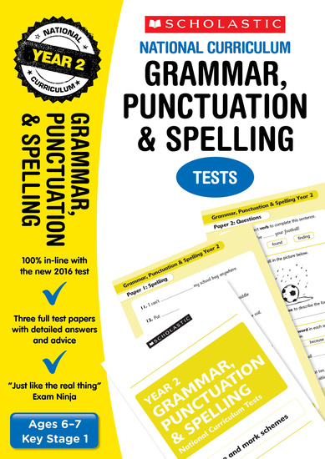
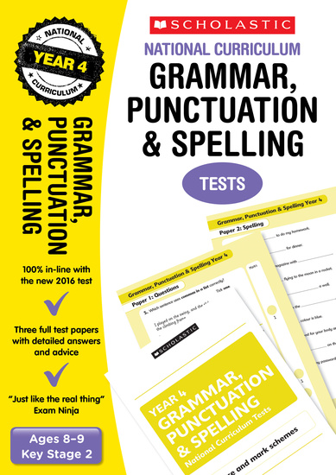
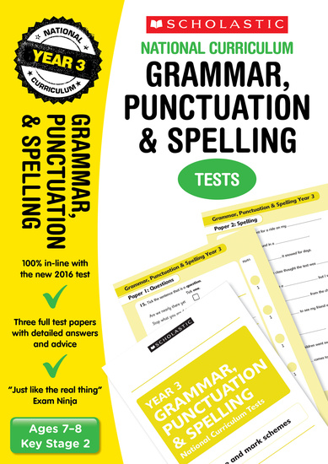
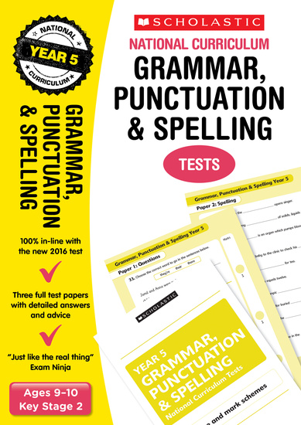
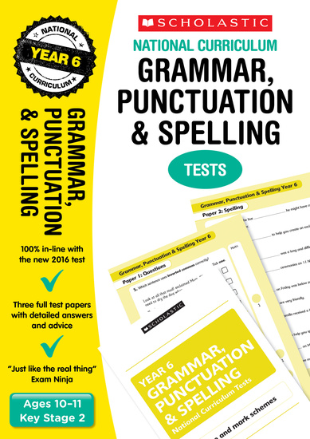
Year 2
Year 2
Year 2
Year 5
Year 6
Year 4
Year 3
Year 2
---------------------------------------------------------------------------------------------------------------------------------------------------------
Name of child:_ _ _ _ _ _ _ _ _ _ _ _ _ _ _ _ _ _ _ _ _ _ _ _ _ _ _ _ _ _ _ _ _ _ _
Class: _ _ _ _ _ _ _ _ _ _ _ _ _ _
I agree to purchase the below and I enclose the amount of £:_ _ _ _ _ _ _
Signed: _ _ _ _ _ _ _ _ _ _ _ _ _ _ _ _ _ _ _ _ _ _ _ _ _ _ Date:_ _ _ _ _ _ _ _ _ _ _ _
Year 2: _ _ _ _ copies
Year 3: _ _ _ _ copies
Year 4: _ _ _ _ copies
Year 5: _ _ _ _ copies
Year 6: _ _ _ _ copies

{Insert School address here}

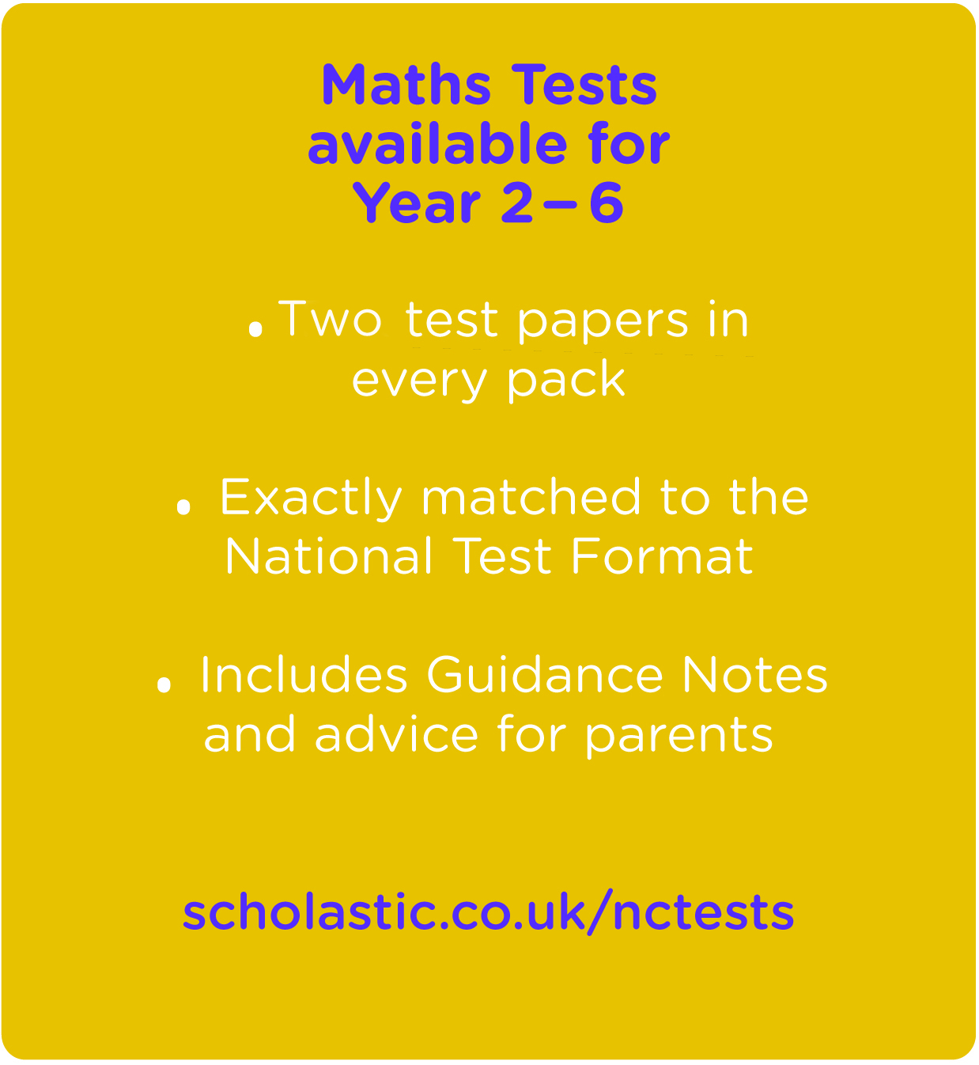
Dear Parents/Carers,
In light of new National Curriculum Tests for years 2 and 6, this term we will be practising and revising our maths skills.
In order to support pupils at home we recommend the Scholastic National Curriculum Tests for Years 2‒6, pictured below.
The test pack includes:
- Two authentic test papers exactly matched to the new test format
- Extra support with guidance notes and tips
The cost of each National Tests pack is £7.99. If you would like to purchase one or more of the test packs please complete and return the reply slip below.
Thank you for your continued support.
Yours sincerely,
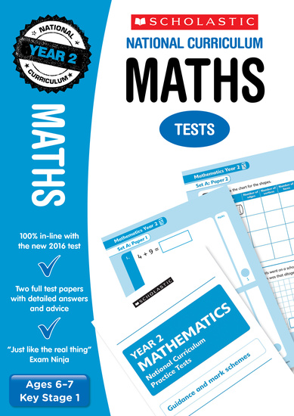
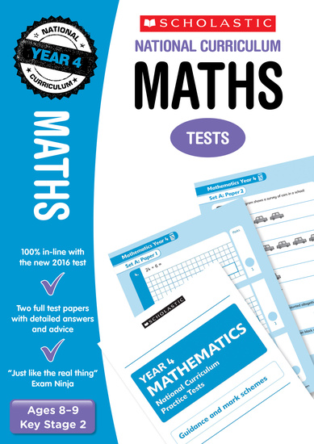
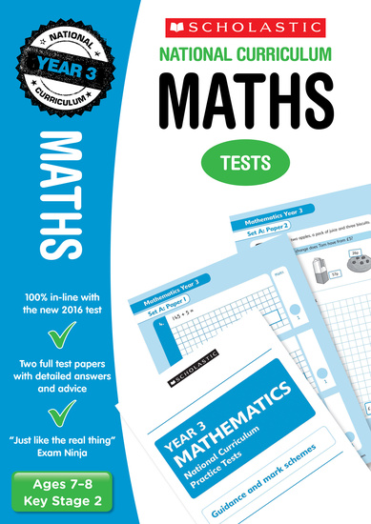
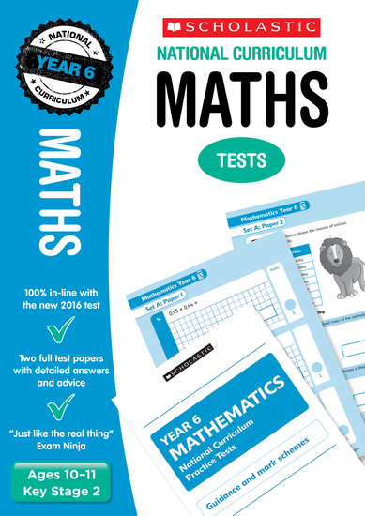
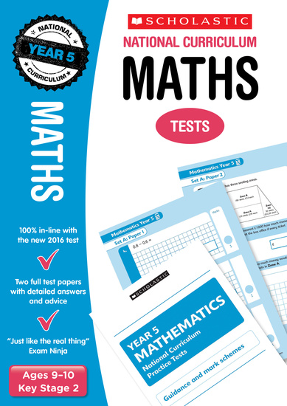
Year 5
Year 6
Year 4
Year 2
Year 3
Year 6
---------------------------------------------------------------------------------------------------------------------------------------------------------
Name of child:_ _ _ _ _ _ _ _ _ _ _ _ _ _ _ _ _ _ _ _ _ _ _ _ _ _ _ _ _ _ _ _ _ _ _
Class: _ _ _ _ _ _ _ _ _ _ _ _ _ _
I agree to purchase the below and I enclose the amount of £:_ _ _ _ _ _ _
Signed: _ _ _ _ _ _ _ _ _ _ _ _ _ _ _ _ _ _ _ _ _ _ _ _ _ _ Date:_ _ _ _ _ _ _ _ _ _ _ _
Year 2: _ _ _ _ copies
Year 3: _ _ _ _ copies
Year 4: _ _ _ _ copies
Year 5: _ _ _ _ copies
Year 6: _ _ _ _ copies

{Insert School address here}

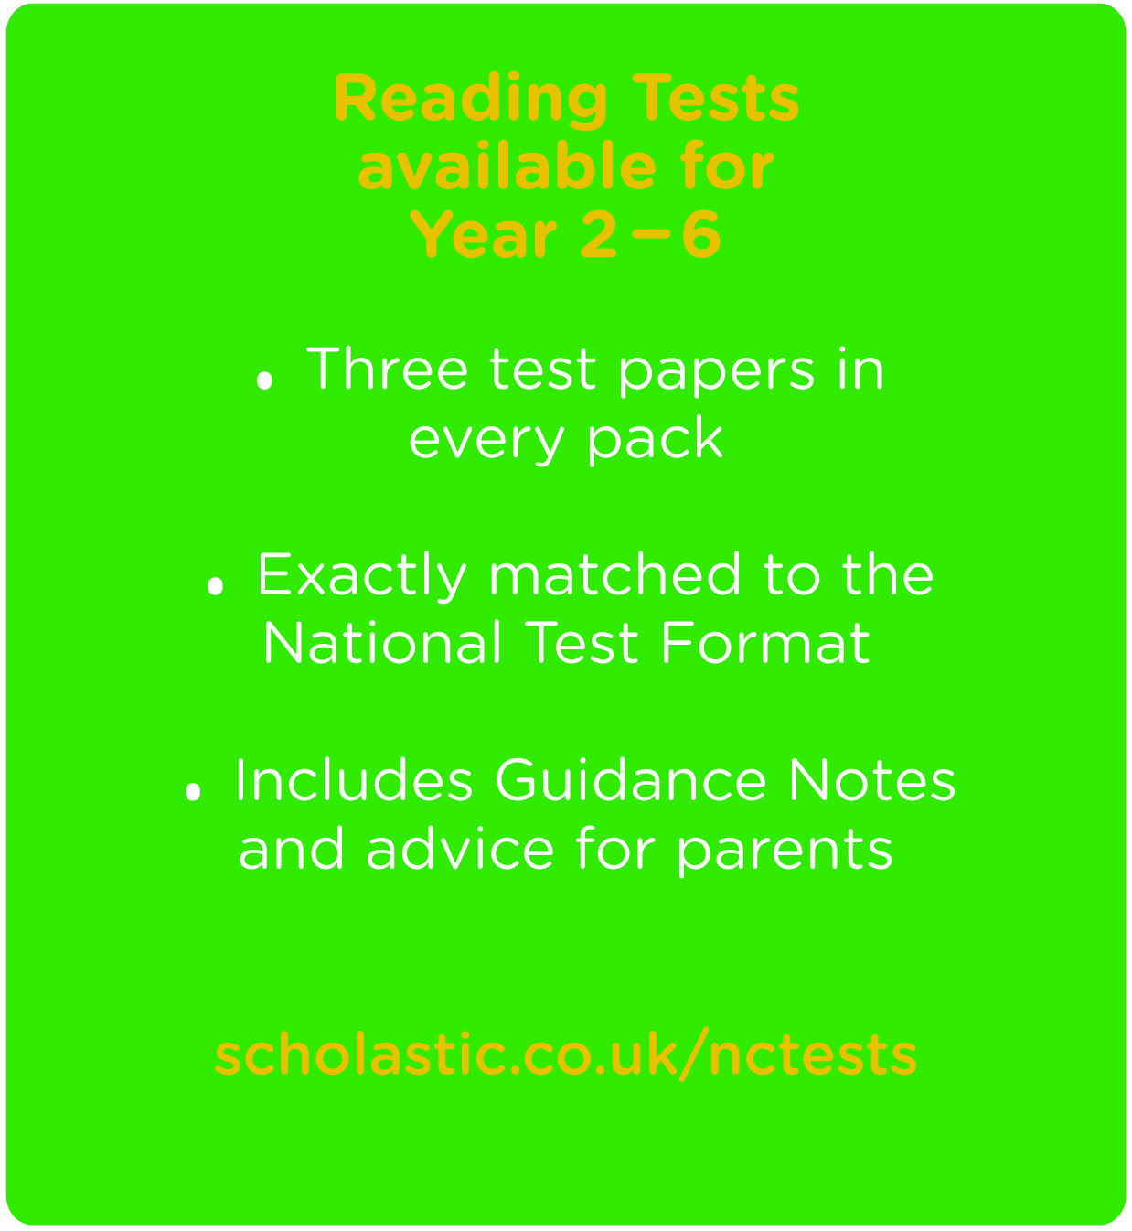
Dear Parents/Carers,
In light of new National Curriculum Tests for years 2 and 6 we will be focusing on our reading and comprehension skills for the next two terms.
In order to support pupils at home we recommend the Scholastic National Curriculum Tests for Years 2‒6, pictured below.
The test pack includes:
- Three authentic test papers exactly matched to the new test format
- Extra support with guidance notes and tips
The cost of each National Tests pack is £7.99. If you would like to purchase one or more of the test packs please complete and return the reply slip below.
Thank you for your continued support.
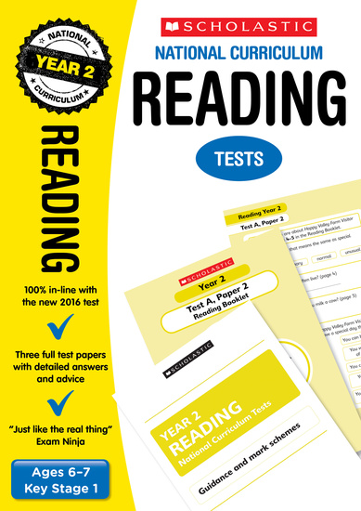
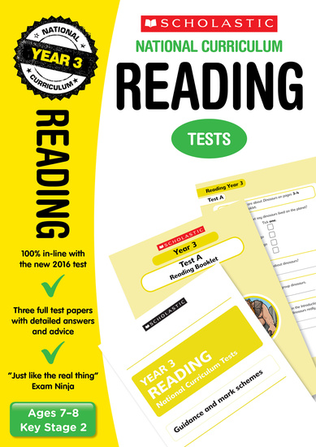
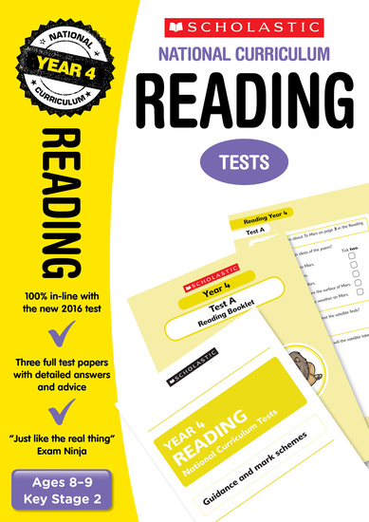
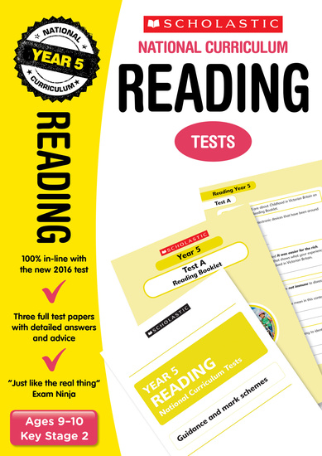
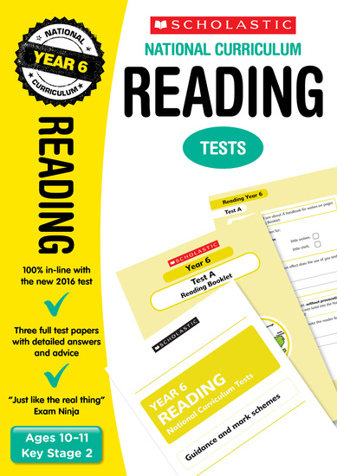
Yours sincerely,
Year 5
Year 6
Year 4
Year 2
Year 3
---------------------------------------------------------------------------------------------------------------------------------------------------------
Name of child:_ _ _ _ _ _ _ _ _ _ _ _ _ _ _ _ _ _ _ _ _ _ _ _ _ _ _ _ _ _ _ _ _ _ _
Class: _ _ _ _ _ _ _ _ _ _ _ _ _ _
I agree to purchase the below and I enclose the amount of £:_ _ _ _ _ _ _
Signed: _ _ _ _ _ _ _ _ _ _ _ _ _ _ _ _ _ _ _ _ _ _ _ _ _ _ Date:_ _ _ _ _ _ _ _ _ _ _ _
Year 2: _ _ _ _ copies
Year 3: _ _ _ _ copies
Year 4: _ _ _ _ copies
Year 5: _ _ _ _ copies
Year 6: _ _ _ _ copies

